МИНИСТЕРСТВО НАУКИ И ВЫСШЕГО ОБРАЗОВАНИЯ  
РОССИЙСКОЙ ФЕДЕРАЦИИ

федеральное государственное автономное   
образовательное учреждение высшего образования  
«Самарский национальный исследовательский университет   
имени академика С.П. Королева»

(Самарский университет)

Институт информатики, математики и электроники

Факультет информатики  
Кафедра суперкомпьютеров и общей информатики

**Отчет по лабораторной работе № 2**

Дисциплина: «Enterprise Systems Development (Методы проектирования и поддержки требований к программному обеспечению)»

Вариант 14

Тип предприятия: **« Photo services use case scenarios »**

Выполнил: Бабонин Д.А.

Группа: 6133-010402D

Самара 2021

**Assignment 2. Use Case diagram**

**Task 1**

Write scenario for each use case using template: use case name, actors, goal, short description, basic script, exceptions (if exist).

**Task 2**

Complete scenarios with examples of documents to be created by your information system. For example, Bill in cafe, Internet invoice, Order in the online store, Medical services bill, etc.

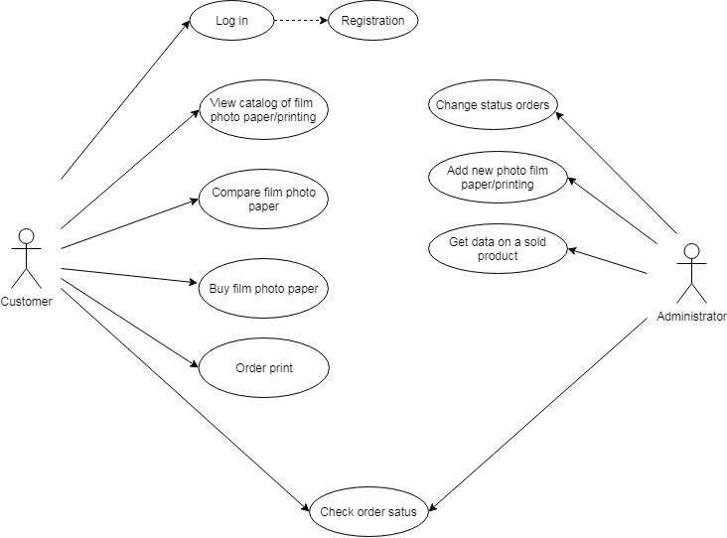

Figure 1 – . The Photo Service store chain. Use Case diagram

**Use Case 1**

**Use Case**: Registration

**Actors:** Customer

**Goal**: Create account

**Short description**: Customer fills out the registration form to create an account in the system

**Scenario**:

1. Customer goes on the website of photo service store

2. Click button “Registration”

3. Fills registration form

4. Click button “Create account”

Exception 1: This customer already exists.

5. Send email for confirm registration

6. Customer follows the link from the email to complete the registration

7. Customer complete registration

**Use Case 2**

**Use Case**: Log in

**Actors**: Customer

**Goal**: Login to account

**Short description**: Customer fills out the login form to sign in an account

**Scenario**:

1. Customer goes on the website of photo service store

2. Customer fills form to log in

3. Customer click button “Log in”

Exception 1: Login or password is incorrect

4. Customer is redirect to main page

**Use Case 3**

**Use Case:** View catalog of services

**Actors:** Customer

**Goal:** View Products Available

**Short description:** Customer views catalog services

**Scenario:**

1. Customer goes on the website of photo service store
2. Customer views services
3. Customer go to page «Photo paper» and view price list with information about photo paper

View: Products are listed one after another

Characteristics: product features shown in the product list. (name, price, iso, images, reviews, rating)

Filters: Customer can filter product by name, price, year, category by decreasing or increase

1. Search: Customer can search product by name, price, year, category
2. Customer go to page «Printing photo» and view price-list with information about print

View: Products are listed one after another

Characteristics: product features shown in the product list. (price, paper, size, production time)

**Use Case 4**

**Use Case:** Compare film photo paper

**Actors:** Customer

**Goal:** Compare products

**Short description:** Compare the characteristics of several photo paper

**Scenario:**

1. Customer goes on the website of photo service store
2. Customer views services
3. Customer go to page «Photo paper» and view price list with information about photo paper
4. Customer clicks button «add to comparison» on multiple products
5. Customer clicks button «Compare products»
6. Customer redirected to product comparison page

|  |  |  |
| --- | --- | --- |
|  | **Photo Paper 1** | **Photo Paper 2** |
| **price** | 599 | 1000 |
| **iso** | 200 | 400 |
| **rating** | 5.0 | 4.4 |

**Use Case 5**

**Use Case:** Buy photo paper

**Actors:** Customer

**Goal:** Purchase product

**Short description:** Purchase selected product

**Scenario:**

1. Customer goes on the website of photo service store
2. Customer log in

**Exception 1: Login or password is incorrect**

1. Customer views services
2. Customer go to page «Photo paper» and view price list with information about photo paper
3. Customer selected film paper
4. Customer click button «Buy»
5. Product add to «shopping basket»
6. Customer can continues add product in shopping basket (point 3-4) or go to payment page
7. Customer fills out form with type pay, delivery and address

Input form:

Pay(dropdawn): bank card or cash

Delivery(dropdawn): pickup or courier delivery

Address(text): customer address

1. Create a unique order number
2. The calculation of the cost of delivery

**Exception 2: Fill all necessary fields**

1. Customer redirected to page with information about order
2. Send email to customer

|  |  |  |  |  |
| --- | --- | --- | --- | --- |
| **Order date** | **Order number** | **Customer name** | **Delivery status** | **Payment status** |
| 04.04.2021 | 3 | Test User | In stock | Cash(Waiting) |

**Use Case 6**

**Use Case:** Print order

**Actors:** Customer

**Goal:** Purchase product

**Short description:** Purchase selected product

**Scenario:**

1. Customer goes on the website of photo service store

2. Customer log in

Exception 1: Login or password is incorrect

3. Customer go to page «Printing Photo»

4. Customer click “Order photo”

5. Заказчик переходит на страницу оформления заказа

6. Заказчик заполняет поля: тип печати, тип бумаги, ссылка на архив фотографий

7. Customer fills out form with type pay, delivery and address

Input form:

Pay(dropdawn): bank card or cash

Delivery(dropdawn): pickup or courier delivery

8. Заказчик переходит на страницу «Оплата», выбирает тип оплаты и заполняет данные об оплате

Exception 2: Fill all necessary fields

9.

10. Create a unique order number

11. Customer redirected to page with information about order

12. Send email to customer

**Use Case 6**

**Use Case:** Check order status

**Actors:** Administrator / Customer

**Goal:** Get data about status order

**Short description:**  View status order

**Scenario:**

1. Administrator / Customer goes on the website of photo service store

2. Administrator / Customer log in

Exception 1: Login or password is incorrect

3. Administrator / Customer click button “Status orders”

4. Administrator / Customer is redirect to page list status orders

Order status type: In stock, Courier took the order, Delivered

Payment status type: Bank card(waiting), Cash(waiting), Paid

|  |  |  |  |  |  |  |  |
| --- | --- | --- | --- | --- | --- | --- | --- |
| **Date order** | **Order numder** | **Customer name(for only admin)** | **Product** | **Quantity** | **Sum, rub** | **Status** | **Payment** |
| 04.04.2021 | 3 | Test User | Kodak Gold 200-24 | 3 | 599,00 | In stock | Paid |
| 04.04.2021 | 3 | Test User | FUJI COLOR C200-36 | 1 | 1000,00 | In stock | Paid |
| 04.04.2021 | 5 | Test User | FOMAPAN PROFI 100 | 1 | 399,00 | Delivered | Cash  (waiting) |

**Use Case 7**

**Use Case:** Change order status

**Actors:** Administrator

**Goal:** Change status order

**Short description:** Change status order

**Scenario:**

1. Administrator goes on the website of photo service store

2. Administrator log in

Exception 1: Login or password is incorrect

3. Administrator selects the desired order

4. Administrator click button “Edit status orders”

5. Administrator is redirect to page status order

6. Administrator changes the status order (“In stock” or “Courier took the order” or “Delivered”)

**Use Case 8**

**Use Case:** Edit / Add new photo paper

**Actors:** Administrator

**Goal:** Edit Photo Paper / Add new paper

**Short description:** Change the output characteristics of a photo paper / Add new product for customers

**Scenario:**

1. Administrator goes on the website of photo service storeAdministrator log in

**Exception 1: Login or password is incorrect**

1. Administrator selects the desired product
2. Administrator click button “Edit” / Administrator click button “Add new product”
3. Redirect to the page with the product information form
4. Administrator adds the necessary fields

Input form: Product name, Price, Quantity, ISO, images

1. Administrator click button “Save”

**Exception 2: Fill all necessary fields**

1. Modified or new photo paper appears on the list

**Use Case 9**

**Use Case:** Delete photo paper

**Actors:** Administrator

**Goal:** Delete photo paper

**Short description:** Delete unnecessary product

**Scenario:**

1. Administrator goes on the website of photo service store
2. Administrator log in

**Exception 1: Login or password is incorrect**

1. Administrator selects the desired product
2. Administrator click button “Delete”
3. Dialog box appears confirming the removal of the product.
4. Administrator click button “Yes”

**Use Case 10**

**Use Case:** Get data on a sold products

**Actors:** Administrator

**Goal:** Get data on a sold products

**Short description:** View list of sold products

|  |  |  |  |
| --- | --- | --- | --- |
| **Date** | **Product name** | **Quantity** | **Sum, rub** |
| 04.04.2021 | Kodak Gold 200-24 | 3 | 2799,00 |
| - | - | - | - |
| Total |  |  | 2799,00 |

**Scenario:**

1. Administrator goes on the website of photo service store
2. Administrator log in

**Exception 1: Login or password is incorrect**

1. Administrator click button “Sold products”
2. Redirect to page with list of sold products

**Use Case 11**

**Use Case:** Check order status

**Actors:** Administrator / Customer

**Goal:** Get data about status order

**Short description:** View status order

**Scenario:**

1. Administrator / Customer goes on the website of photo service store
2. Administrator / Customer log in

**Exception 1: Login or password is incorrect**

1. Administrator / Customer click button “Status orders”
2. Administrator / Customer is redirect to page list status orders

Order status type: In stock, Courier took the order, Delivered

Payment status type: Bank card(waiting), Cash(waiting), Paid

Filter:

* Administrator can filter data by date order, customer name, product name, status.
* Customer can filter data date order, product name, status.

Search:

* Administrator can search data by date order, customer name, product name, status, order number.
* Customer can search data date order, product name, status, order number.